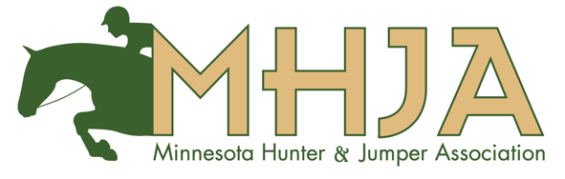
2024 MHJA Horse Show Schedule
Omaha Equestrian Preview - April 18-21, A rated, Elkhorn, NE

Stonegate Spring Classic - April 24-28, Unrated, Cannon Falls, MN
Springtime Sunshine - May 30-June 2, A rated, Elkhorn, NE
Midstates Summerfest - June 5-9, A rated, Mason City IA
Midstates Summer - June 12-16, A rated, Mason City IA
Stonegate Summer Classic - July 11-14, Unrated, Stillwater, MN

Two Rivers Summer Fest I - July 31- August 4, A rated, Cumming, IA
Two Rivers Summer Fest II - August 9-13, A rated, Cumming, IA
Minnesota State Fair Horse Show - August 16-18, A rated, MN State Fairgrounds
UEE End of Summer – August 29- September 1, A rated, Elkhorn, NE
Midstates Fall - September 11-15, A rated, Mason City IA
Minnesota Harvest Horse Show - October 1-6, A rated, MN State Fairgrounds

